VERSION CONTROL WITH GIT

PRACTICAL 1
AIM: TO UNDERSTAND THE CONCEPT OF VERSION CONTROL ,ITS IMPORETANCE IN MANAGINING PROJECT CHANGES AND EXPLORE DIFFERENT VERSION CONTROL SYSTEMS .
KEY FUNCTION:
- TRACKS EVERY CHANGES MADE TO A FILE..
- ALLOWS MULTILE PEOPLE TO WORK ON THE SME PROJECT WITHOUT CONFLICT .
- ENABLOES REVERTING TO PREVIOUS VERSION IF NEEDED.
- MAINTAINS A HISTORY OF WHO CHNAGED WHAT AND WHEN .
TYPES OD VCS
1.LOCAL VERSION CONTROL :
A LOCAL VERSION CONTROL SYSTEM OPERATES ENTIRELY ON YOUR PERSONAL MACHINE WITHOUT ANY CONNECTION TO A REMOTE REPOSITORY .ALL CHANGES AND VERSION HISTORY ARE STORED IN A LOCAL DATABASE ON YOUR COMPUTER .
2.CENTRALIZED VERSION CONTREOL SYSTEM:
IN A CENTRALIZED VESION CONTROL SYSTEM ,ALL THE FILES and the version history are stored in a single c entral server .this server acts as a the main source for the entire project.developers connect to this server to access or modify files but they do not maintain a full local copy of the project ,installed they work with the most recent versions pulled from the server .
3. DISTRIBUTED VERSION CONTROL SYSTEM
DITRUIBUTED VERSION CONTROL SYSTEMS CONTAIN MULTIPLE REPOSITORIES .EACH USER HAS THEIR OWN RESPOSITORY AND WORKING COPY. JUST COMMITTING YOUR CHNAGES WILL NOT GIVE OTHERS ACCESS TO YOUR CHANGES .THIS IS BECAUSE COMMIT WILL REFLECT THOSE CHANGES IN YOUR LOCAL REPOSITORY AND NEED TO PUSH THEM IN ORDER TO MAKE THEM VISIBLE ON THE CENTRAL REPOSITORY .

PRACTICAL2
AIM :
SET UP GIT ON REMOTE SYSTEM CONFIGURE FOR THE FIRST TIME AND UNDERSTAND THE BASIC CONFIGURATION OPTIONS .\
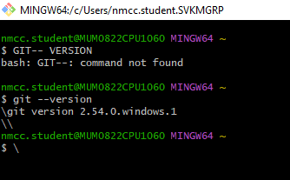
CONFIGURE GIT WITH USERNAME ,EMAIL
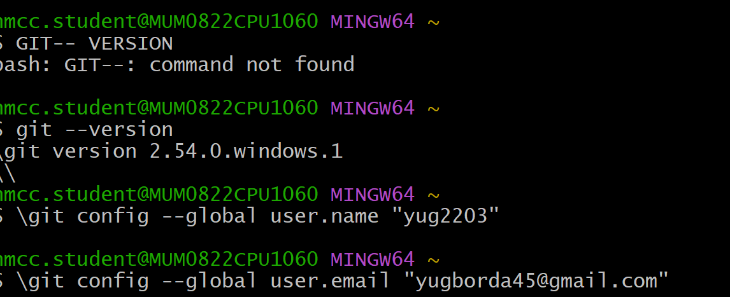

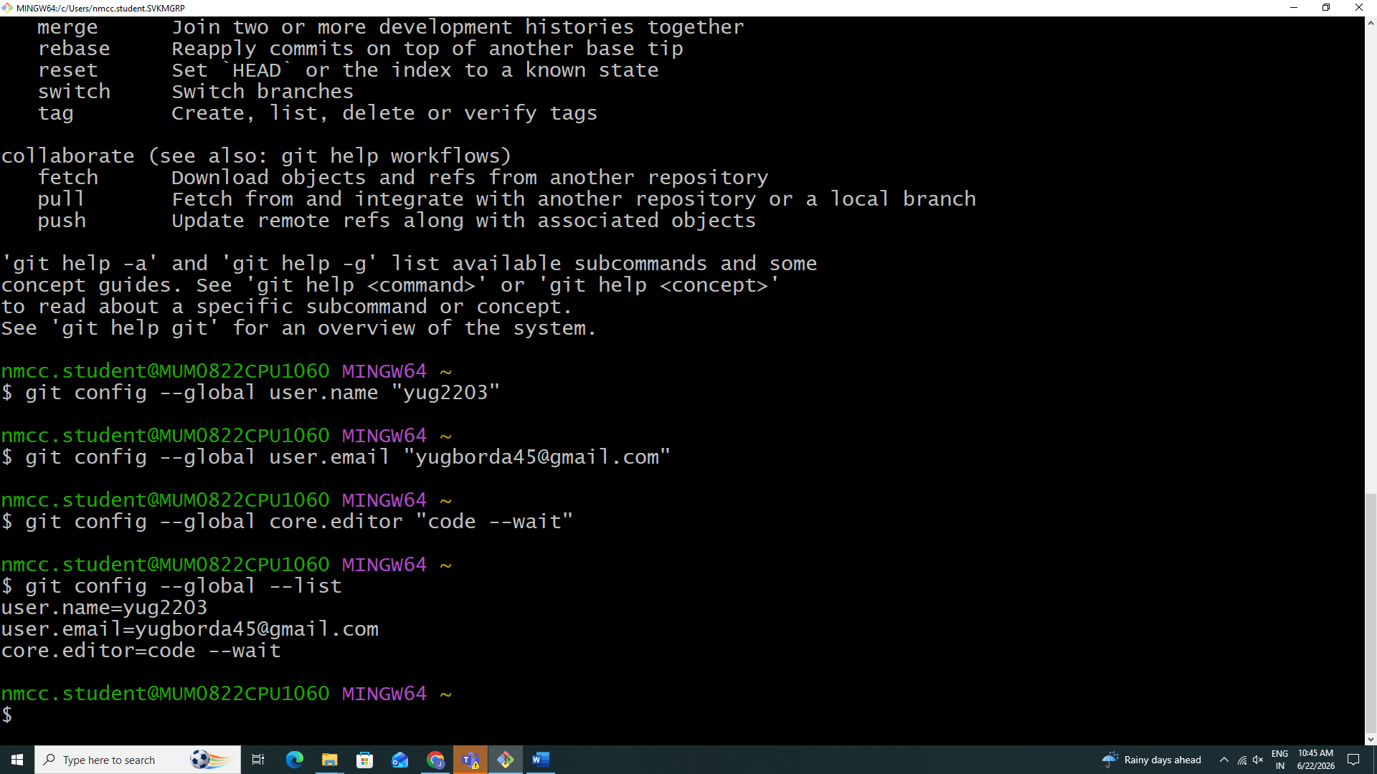
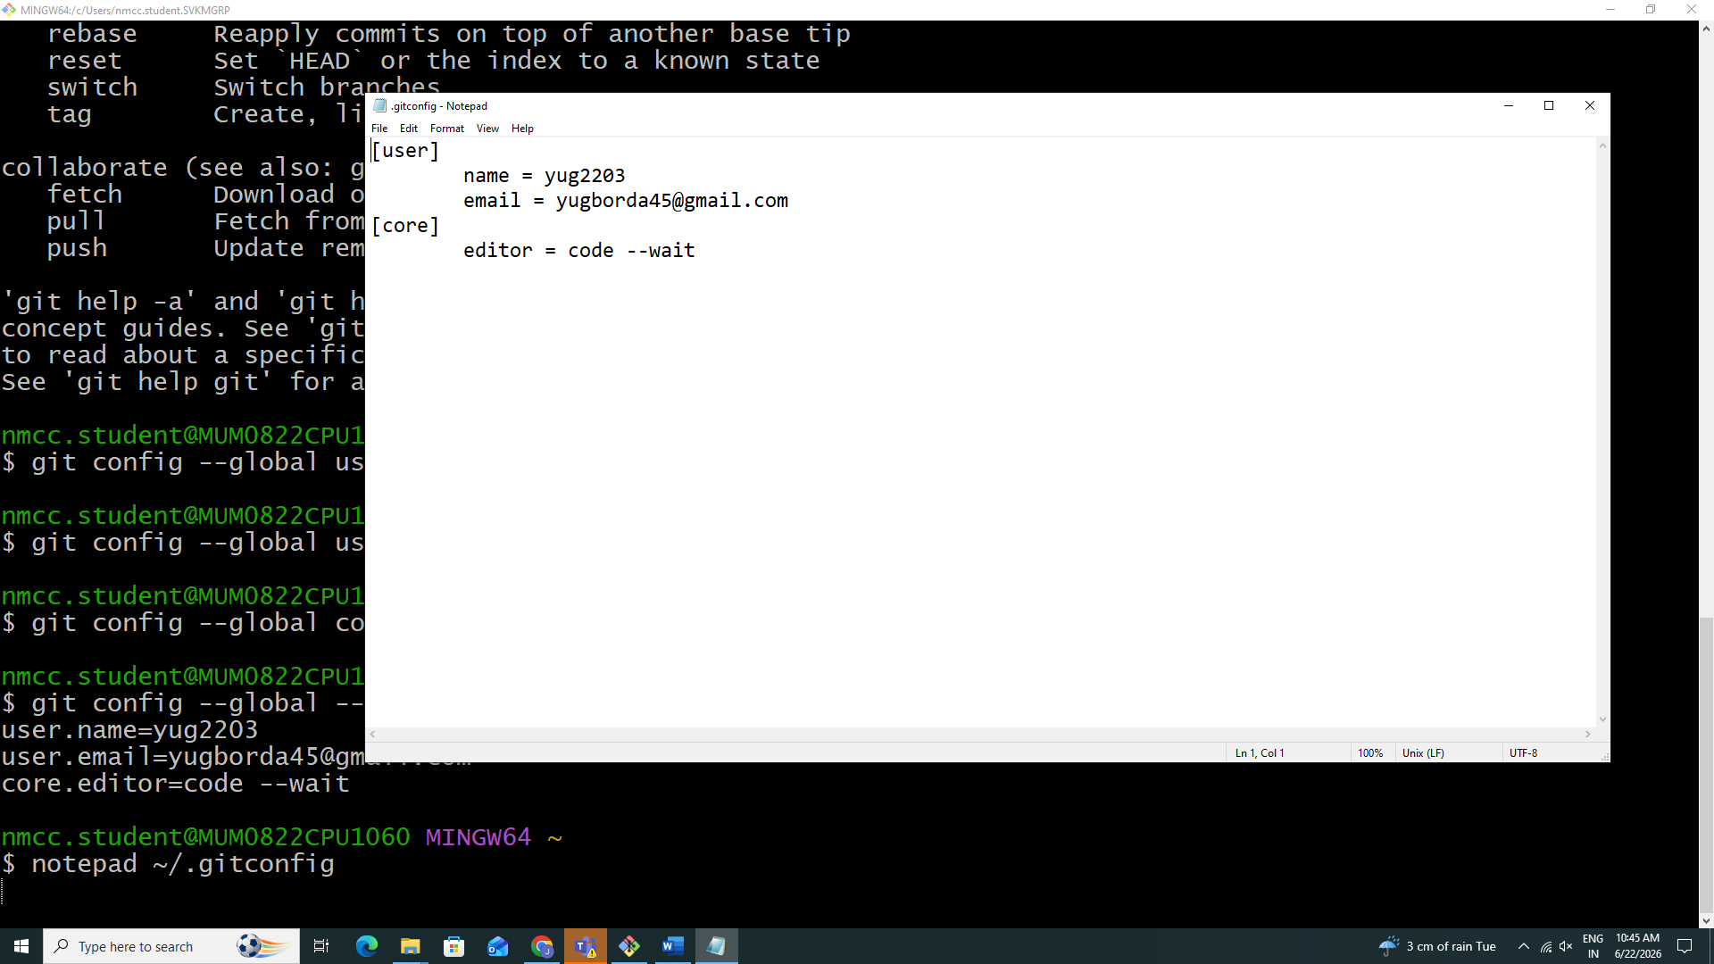

PRATICAL 3
TO EXPLORE GIT HUB AS CLOUD-BASED HOISTING PLATFORM FOR GIT REPOSITORIES AND UNDERSTAND ITS FEATURES AND BENEFITS FOR COLLABORATION AND PORJECT MANAGEMENT
SSH:- SECURESHELL
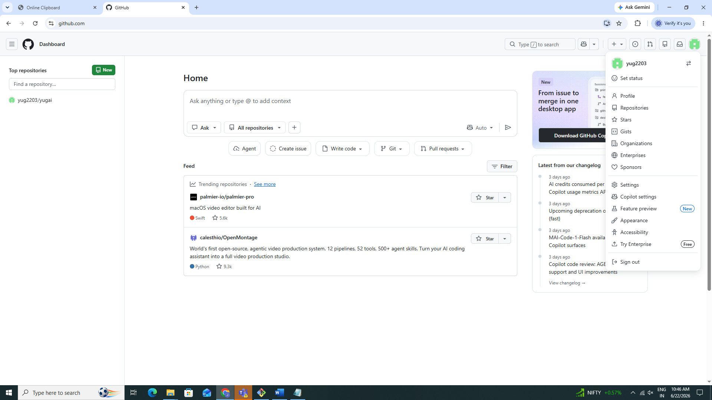

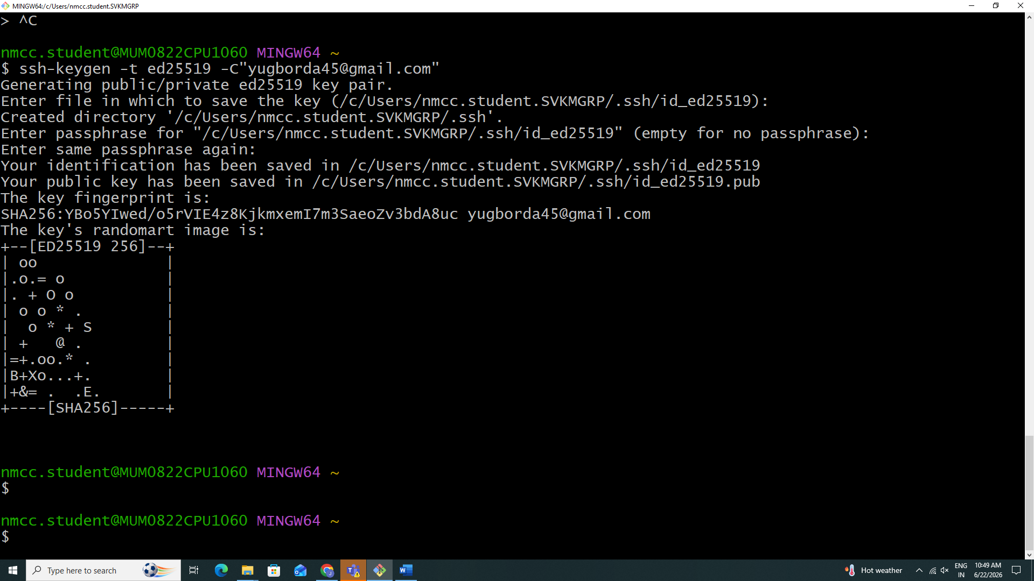
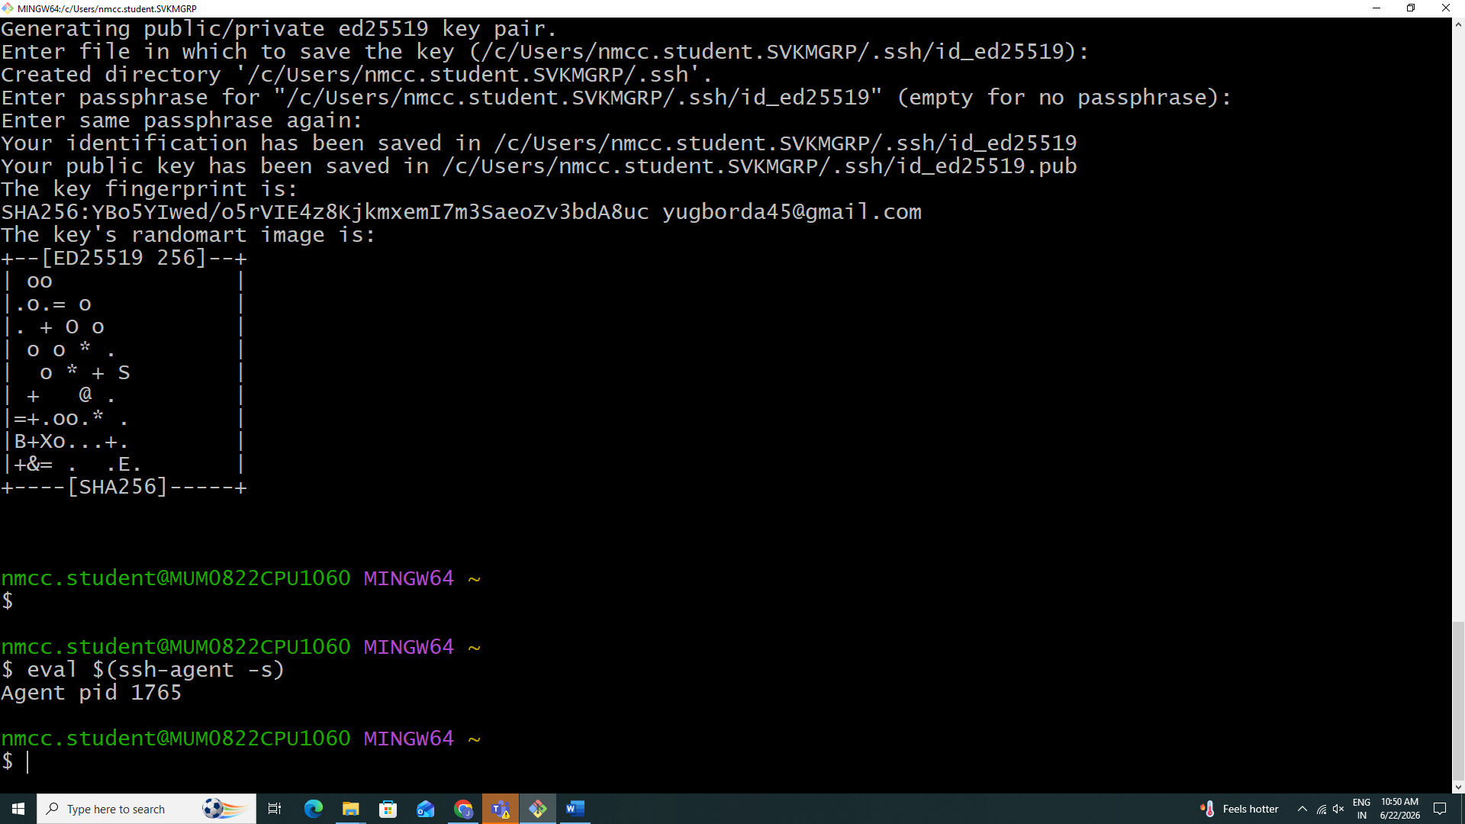

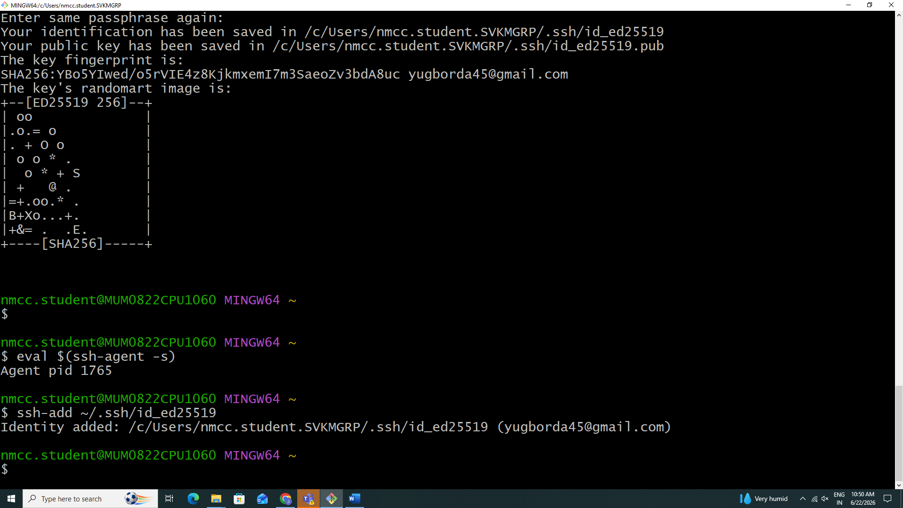
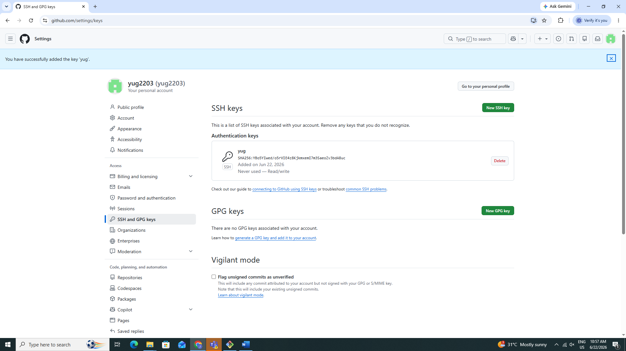

Practical 4
To understand the concept of a git repository and learn to create and initialize a new local repository for tracking project files
Create a new remote repository using github .
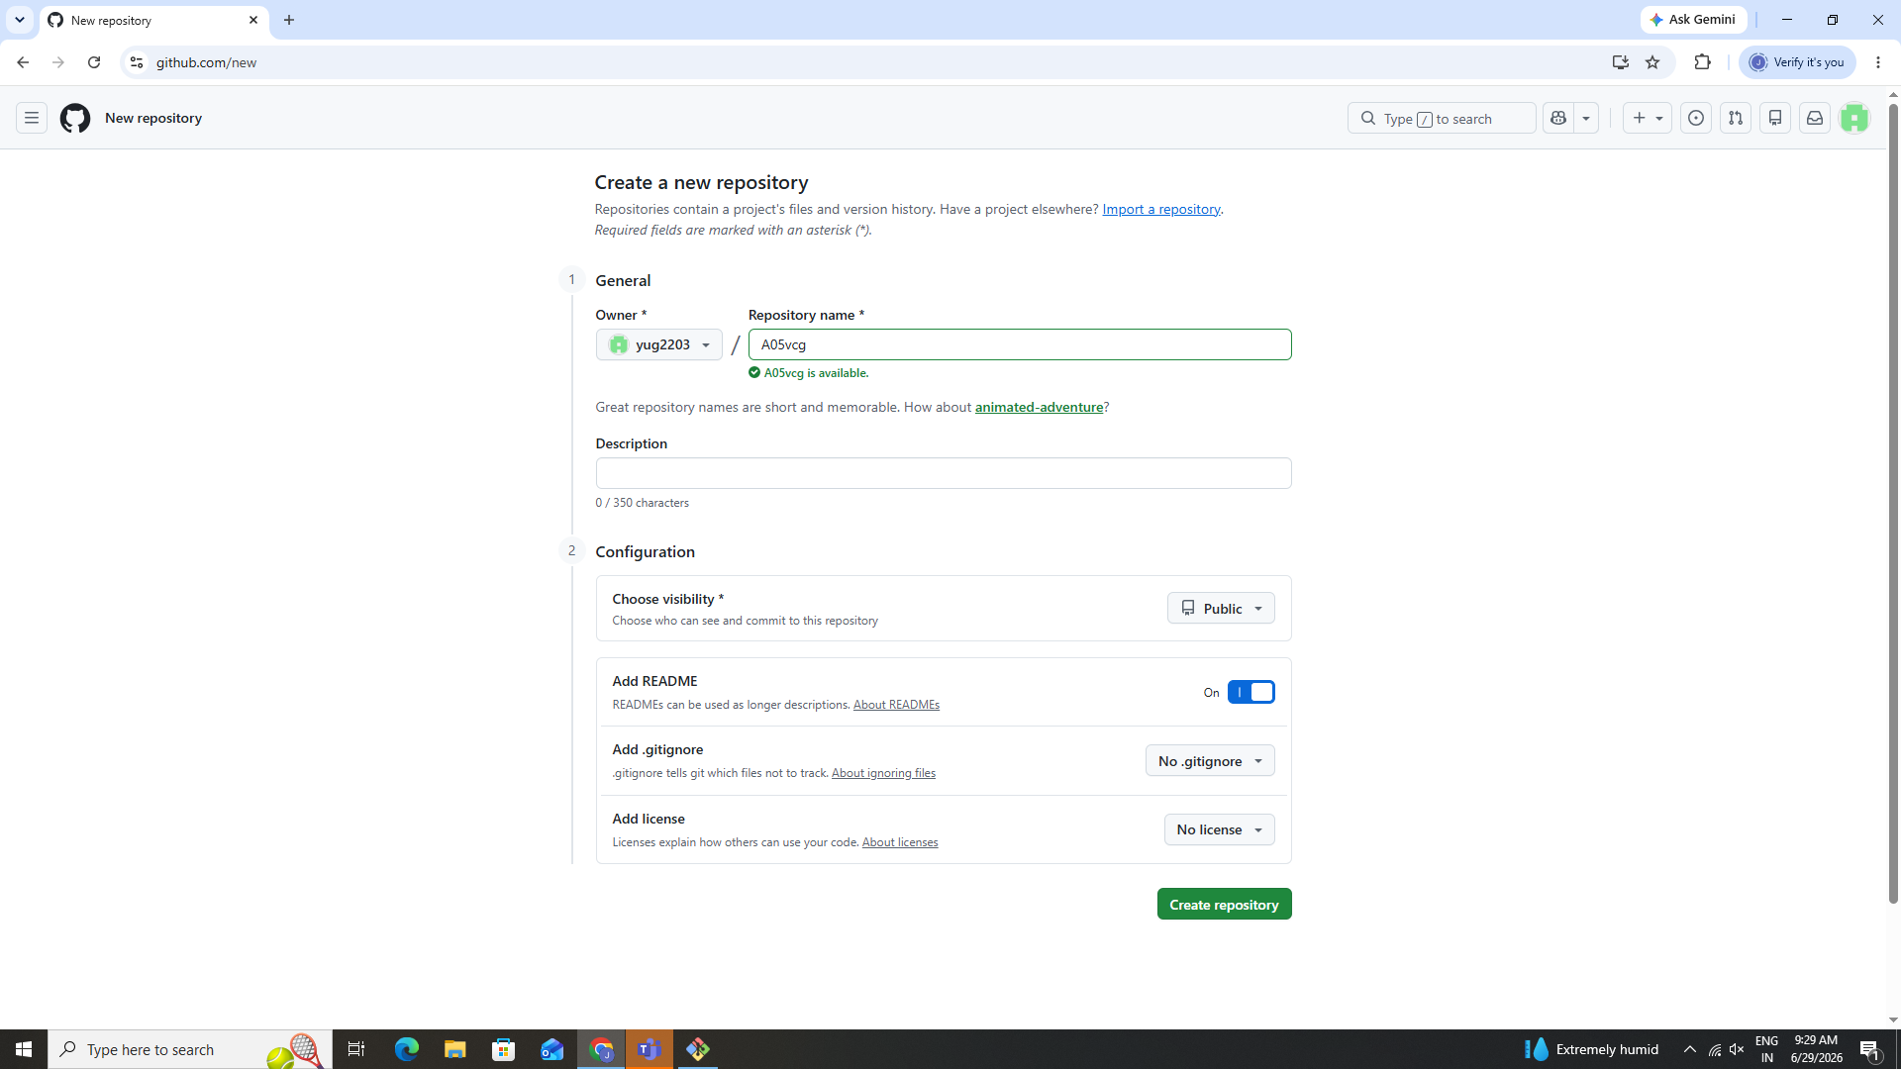
Create new local repository using git init
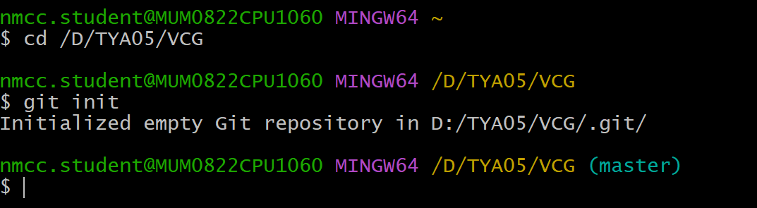
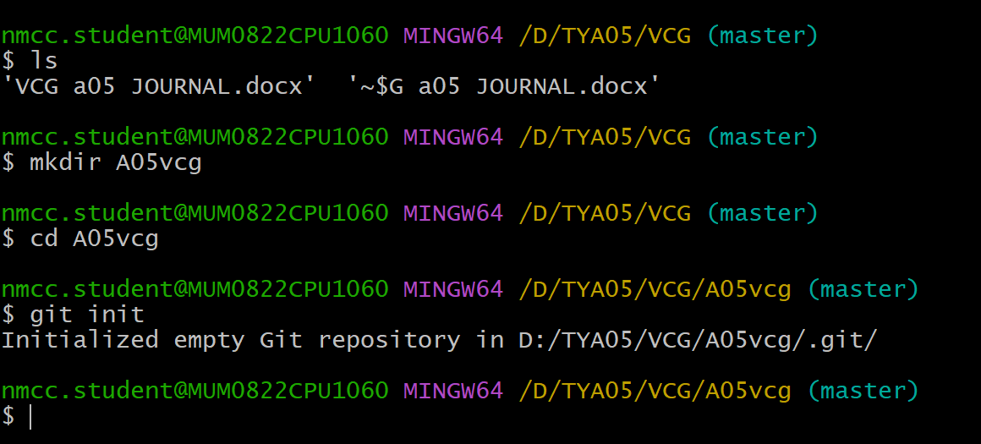
This create a hidden .git holder ,which contains the repository history and configuration

Add and commit files
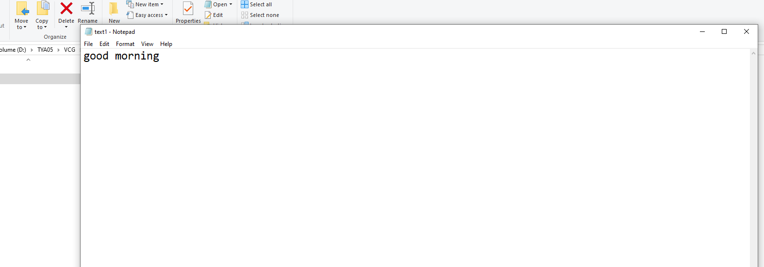
Add the file to staging

Commit the file
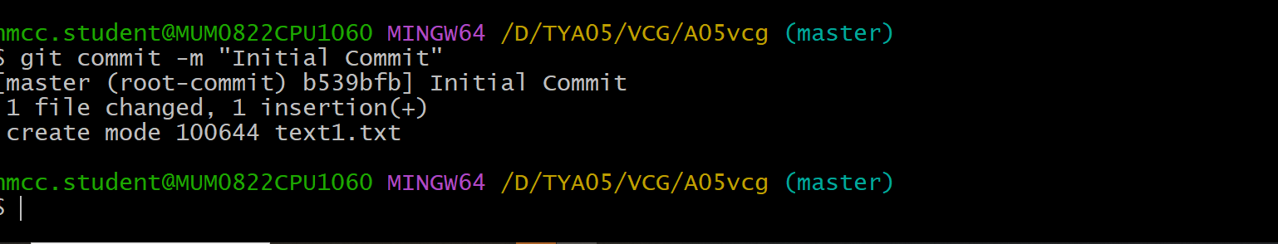
Add remote repository
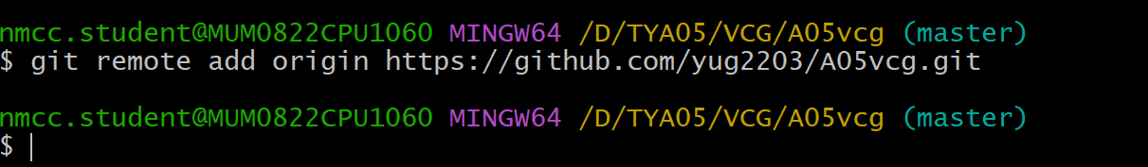
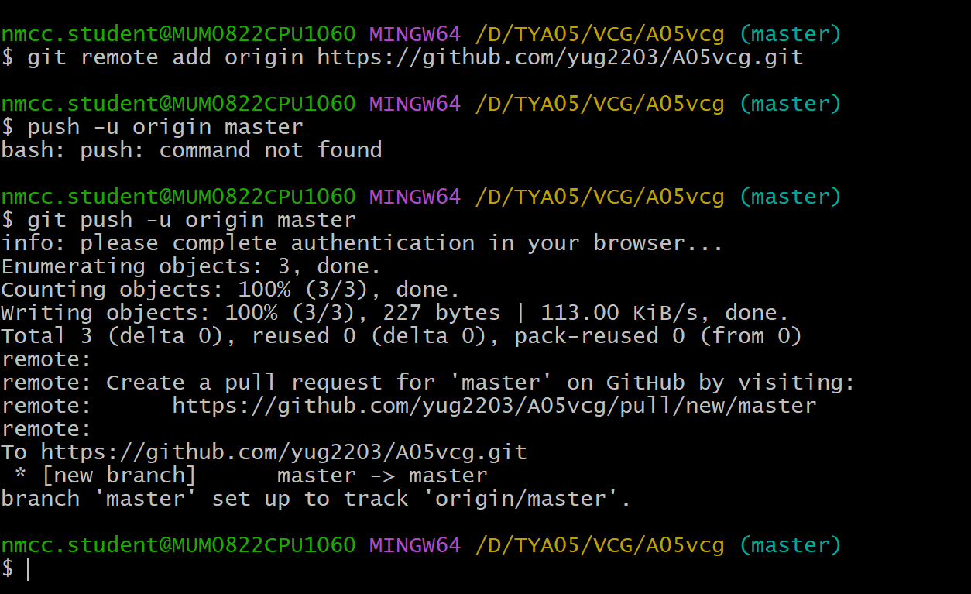
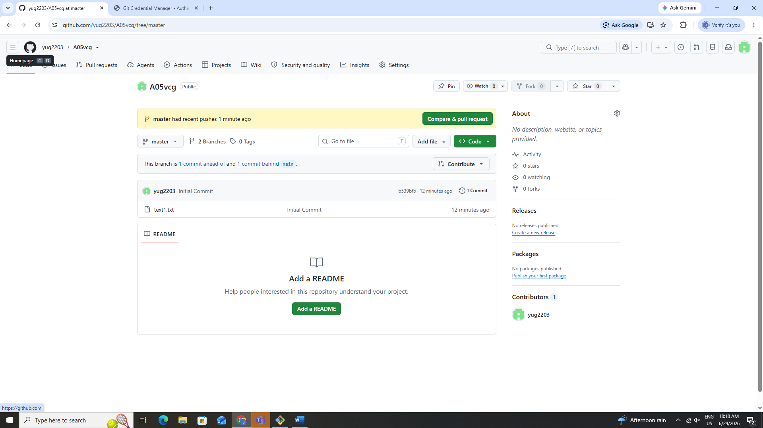
Practical 5
